All welcome to join the Axbridge Branch Walk & Ring

Sat 26th July ‘25

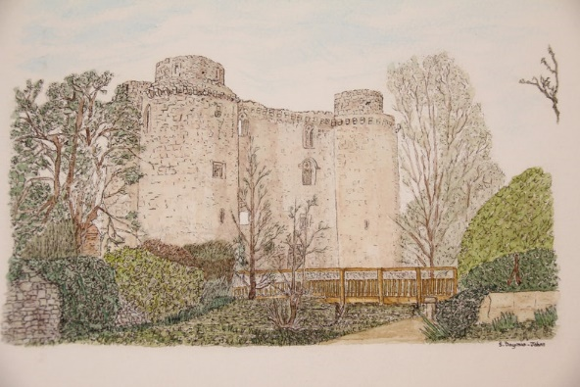
Mells, bells and a Castle

1.45 – 2.30pm Mells St Andrew BA11 3PW 8 26-2-23 (T)
**At Mells we are ringing after a wedding so start time may be different.

60 mins walk to:
3.30 – 4.15pm Whatley St George BA11 3LE 6 11-3-25 (GF)

60 mins walk to:
5.30 – 6.15pm Nunney All Saints BA11 4LW 6 12cwt
**We cannot ring at Nunney before 5.30pm.

- Walkers, drivers, cyclists all very welcome!
- Lift shares appreciated to return walkers to cars.
- £1 per person per tower please.
- Toilets at Mells. Toilet in the pub at Nunney.

Pop Up’ Cream Tea, at Nunney Church @ 6pm

